
The Langley Ukulele Ensemble
director: Paul Luongo 778.840.0635
director_paul@langleyukes.com

Technical Information 2024
Contact person for technical info: Brendon Tjepkema
e-mail: sound@langleyukes.com
Performance Requirements:
The Langley Ukulele Ensemble consists of 26 ukulele players, a director and one upright acoustic bass player.
On stage:
We require a performance area of 24’ wide by 12’ deep.
13 armless chairs set up in an arc, and space in front for the director to stand and for individual vocal or instrument solos.
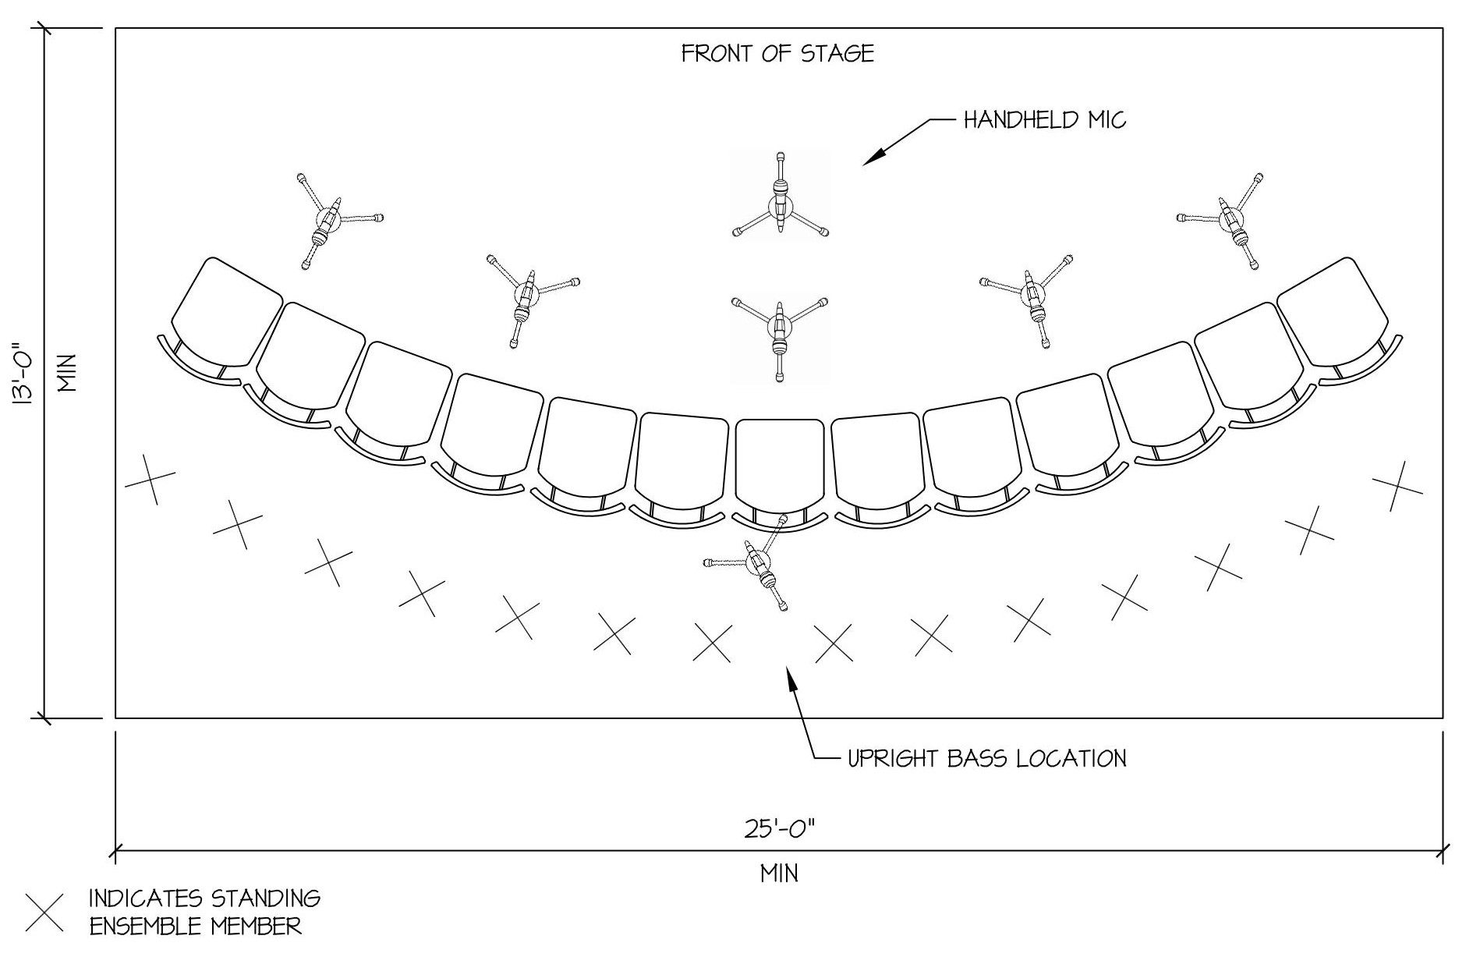

Technical:
- We use two Rode M5 Condenser microphones placed at the ¼ points to pick up the group's voices and instruments. (4 channels--require phantom power)
- We use 3 Audio Technica AE5100 condenser mikes at equal points at chest height in front of the group to pick up voices and ukuleles. (3 channels)
- We use one (preferably wireless) vocal microphone for the director to speak with the audience and for vocal solos and duets. (1 channel)
- The upright bass will have a contact microphone or if we are travelling by air we will bring an electric upright bass and we will need a bass amp. (1 channel).
- We amplify between 1 & 5 ukuleles (1 minimum) with 1/4" instrument plug- ins, requiring DI boxes. We may instead use EV wireless belt pack systems with mini XLR instrument cables for solo ukuleles, or a combination of both systems.
- We supply our own digital mixing console and only require two inputs on stage.
Monitors:
Monitors are not required.
Sound operation:
Because of the unique and sometimes unpredictable dynamics of the performance the Langley Ukulele Association will provide either:
1) A sound system operator or
2) A member to provide cues for the event’s sound system operator.
Equipment we can provide upon agreement with director:
All microphones, wireless equipment and microphone stands.
If the venue does not already have a sound system in place we can supply our own 24 channel Presonus digital mixing board, 150’ Digiflex snake and speakers as well as all necessary cables.
What we need from you:
13 chairs on a minimum 25’ x 13’ performance area.
A small area, with a minimum 2' x 3' table to set up our sound board if one is not already provided, with good sightlines to the stage, and within reasonable reach of a power outlet. If you provide the sound board we will require a minimum of 8 channels and phantom power on five channels. If a sound system is already on site we will need access to the sound control area to either run the sound board or to cue the operator.
Green room:
The group will also need a warm up area with 27 chairs and a suitable area to leave ukulele cases and personal effects while they perform. This area must be secure to prevent theft. Drinking water (no plastic bottles please) should be provided. You are very welcome to provide snacks.
For Merchandise (if allowed):
A table (3ft x 5ft) in a visible location, eg. the foyer, for CD and T-shirt sales.

